**Practical-4**

Implement a function of sequential search and count the steps executed by function on various inputs for best case and worst case. Also write complexity in each case and draw a comparative chart.

Code:

#include <iostream>

using namespace std;

void LinearSearch(int arr[], int len, int item){

for(int i=0;i<len;i++){

if(arr[i] == item){

cout << item << " Found at index : " << i;

return;

}

}

cout << "Not found";

}

int main() {

int arr[] = {10, 5, 15, 21, 30, 7};

// calculating length of array

int len = sizeof(arr)/sizeof(arr[0]);

// item to be searched

int item = 21;

LinearSearch(arr, len, item);

return 0;

}

**Output:**

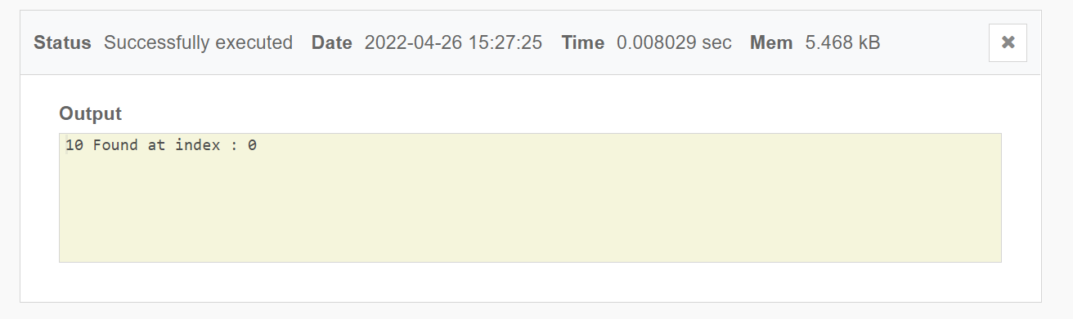

**BEST CASE:**

|  |  |
| --- | --- |
| **Size of Array** | **Time complexity** |
| **5** | **0.008029** |
| **10** | **0.008545** |
| **15** | **0.00833** |
| **20** | **0.010289** |

**WORST CASE:**

|  |  |
| --- | --- |
| **Size of Array** | **Time complexity** |
| **5** | **0.007772** |
| **10** | **0.007694** |
| **15** | **0.008963** |
| **20** | **0.007157** |

**COMPARISION CHART:**

|  |  |  |
| --- | --- | --- |
| **Size of Array** | **Best case** | **Worst case** |
| **5** | **0.008029** | **0.007772** |
| **10** | **0.008545** | **0.007694** |
| **15** | **0.00833** | **0.008963** |
| **20** | **0.010289** | **0.007157** |

**CONCLUSION:**

**IN THIS PRACTICAL WE EXAMINED THE TIME COMPLEXITY OF SEQUENTIAL SEARCH. FURTHER WE ANALYSED THE BEST AND WORST CASE TIME COMPLEXITY FOR LINEAR SEARCH AND DRAWN A COMPARTIVE GRAPH FOR BOTH CASE.**